**Project Title : “Calculating Family Expenses Using Service Now”**

**Team ID** : NM2025TMID19787

**Team Size** : 4

**Team Leader** : DHAYANIDHI U

**Team member** : BALAKUMAR S

**Team member** : ARISH V

**Team member** : ALEX B

**Acknowledgement:**

We sincerely express our gratitude to our faculty and mentors for their guidance and support throughout this project. Their encouragement, feedback, and valuable insights have been crucial in shaping this work. We also extend our appreciation to the ServiceNow developer community and the resources that helped us implement this project successfully.

# STEP-1:SettingUpServiceNowInstance

* SignIntotheDeveloperAccount

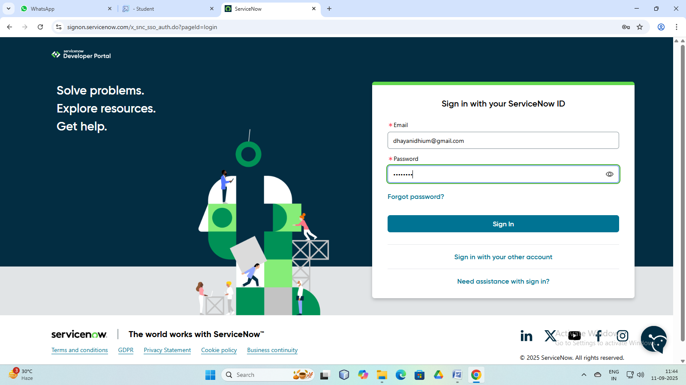

# RequestaPersonalDeveloperInstance(PDI)

* 1. Clickontheprofileiconatthetop-rightcorner.
  2. Select“ManageInstance”orgodirectlytothe link.
  3. Click“RequestInstance”.
  4. Choosethelatestversion(defaultselectionisrecommended).
  5. Click “Request” again.

# AccessyourInstance

1. You’llgetaninstanceURLlike:”https://developer.servicenow.com”
2. Click“OpenInstance”tolaunchit.
3. Youradmincredentials(username&password)willbeshown-copyandsavethem securely.

* LogintoYourInstance

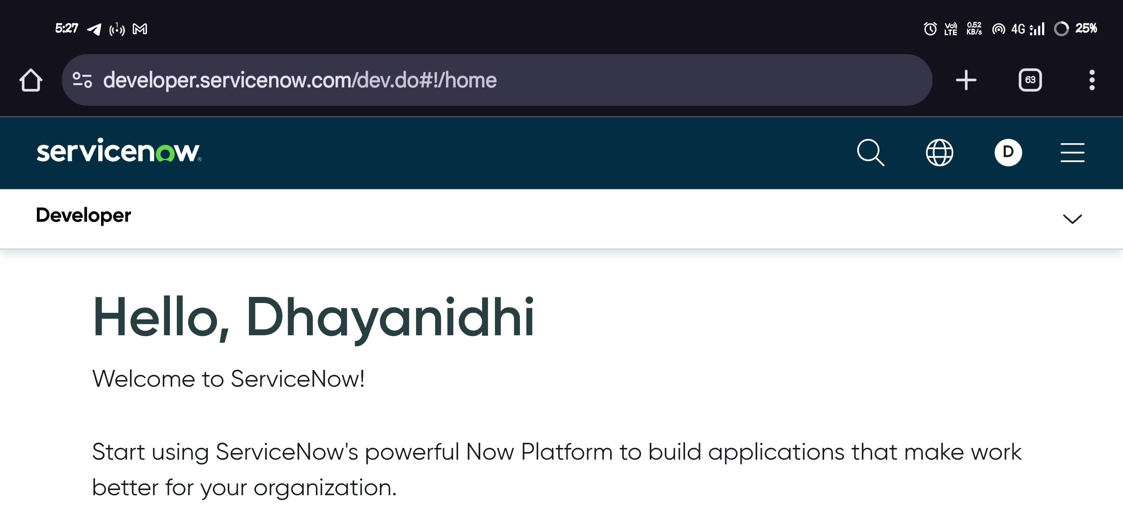

# Step-2:CreationofNewUpdateSet

**KeyObjective**:Track,group,andmanageconfigurationchangesorcustomizationmadeina ServiceNow instance, so they can be migrated or deployed to another instance(like from development to test or production)in a controlled and organized way.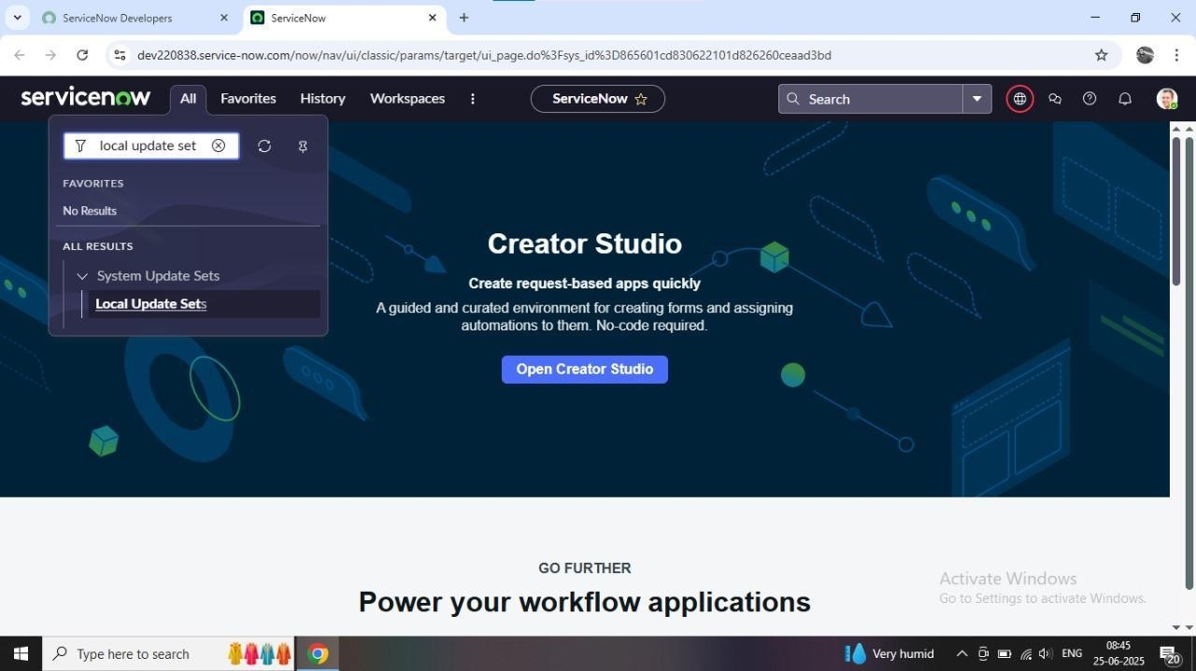

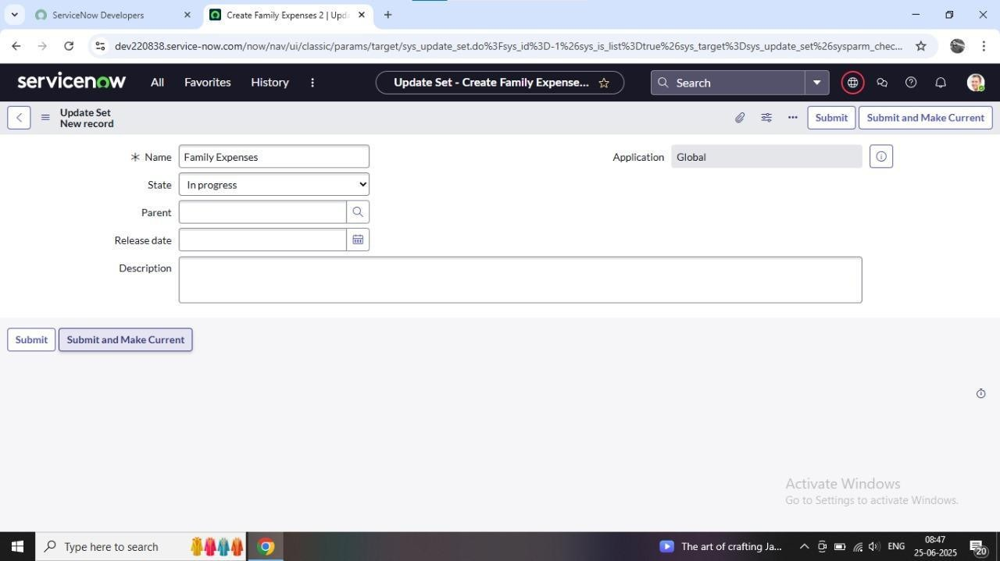

# Step-3:CreationofTable:

* **CreationofFamilyExpensesTabl**
  1. Torecordindividualexpenses(e.g.,food,bills,travel)foreachfamilymember.
  2. Tocategorizeandorganizeexpensesbytype,date,orperson.
  3. Toenablecalculationoftotalandindividualspendingusingscriptsor reports.
  4. Toprovideadigitalsystemformanaginghouseholdfinanceswithinthe ServiceNow platform

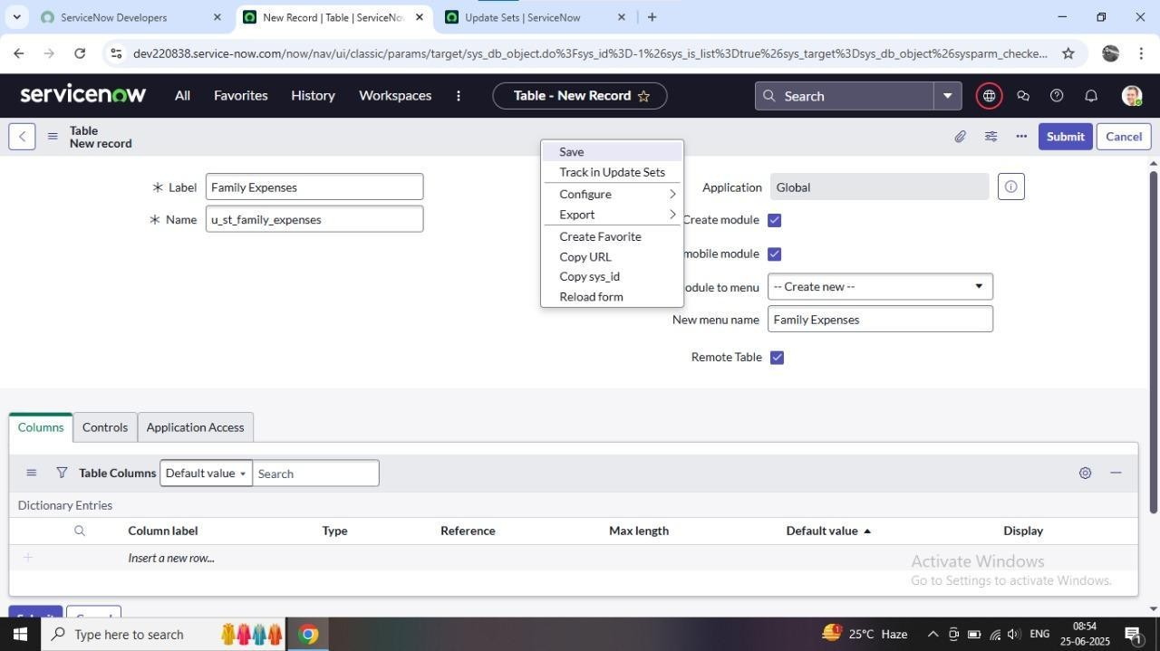

# CreationofColumns(Fields):

**Key Objective:** Creating column fields in the Family Expenses table serves the purpose of capturingdetailedandorganizeddataforeachexpenseentry.Thesefieldsensurethatthedata is structured, easy to query, and meaningful for analysis.

# MakingNumberField AnAuto-Number :ConfigureThe Form:

**KeyObjective:**Customizetheuserinterfacetodisplayonlytherelevantfieldsinaclear, organized,anduser-friendlylayout-makingiteasiertoenter,viewandmanageexpense records efficiently.

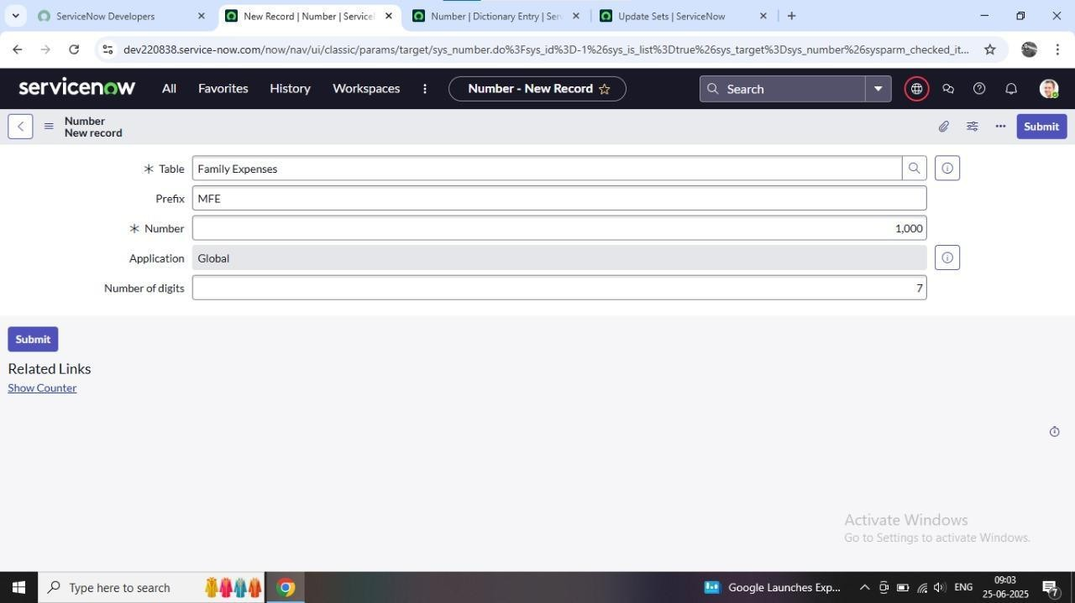

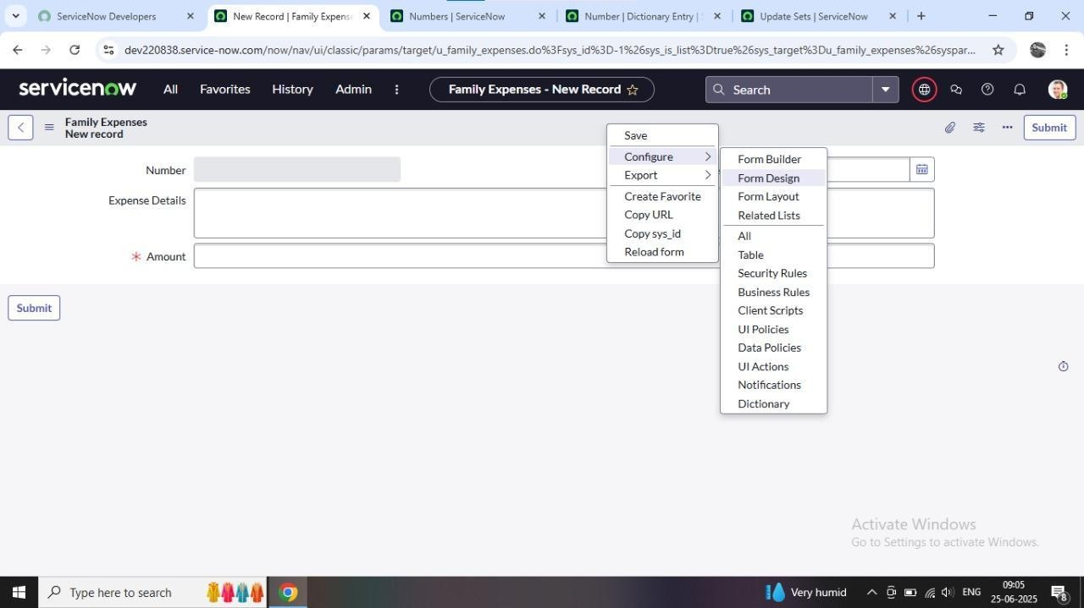

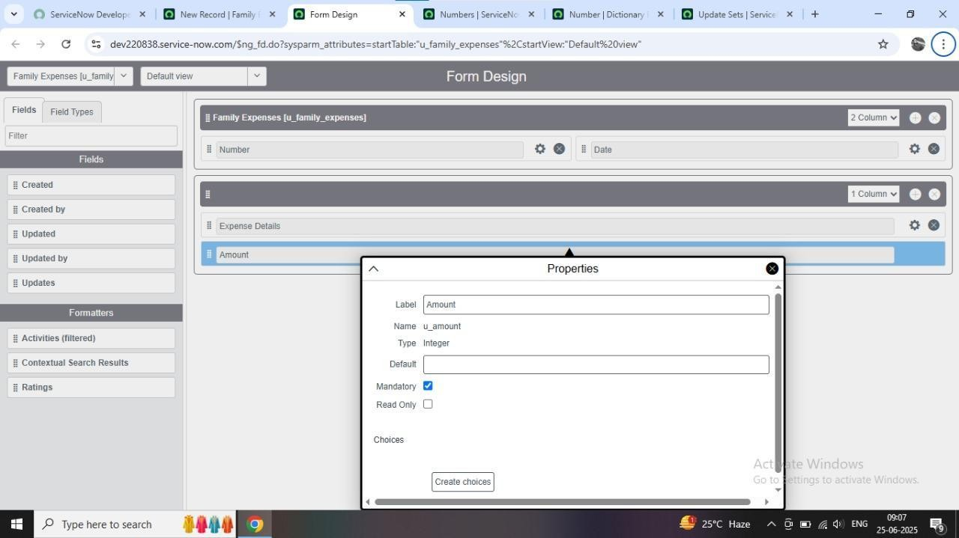

# Step-4:CreationofTable(DailyExpenses)

* **CreationofDailyExpensesTable:**

**Key Objective:** Record and manage everyday spending data in a structured format, enablinguserstotrackdailyfinancialactivity,moniterpatterns,andgenerateuseful

reportsforbudgetingoranalysis.

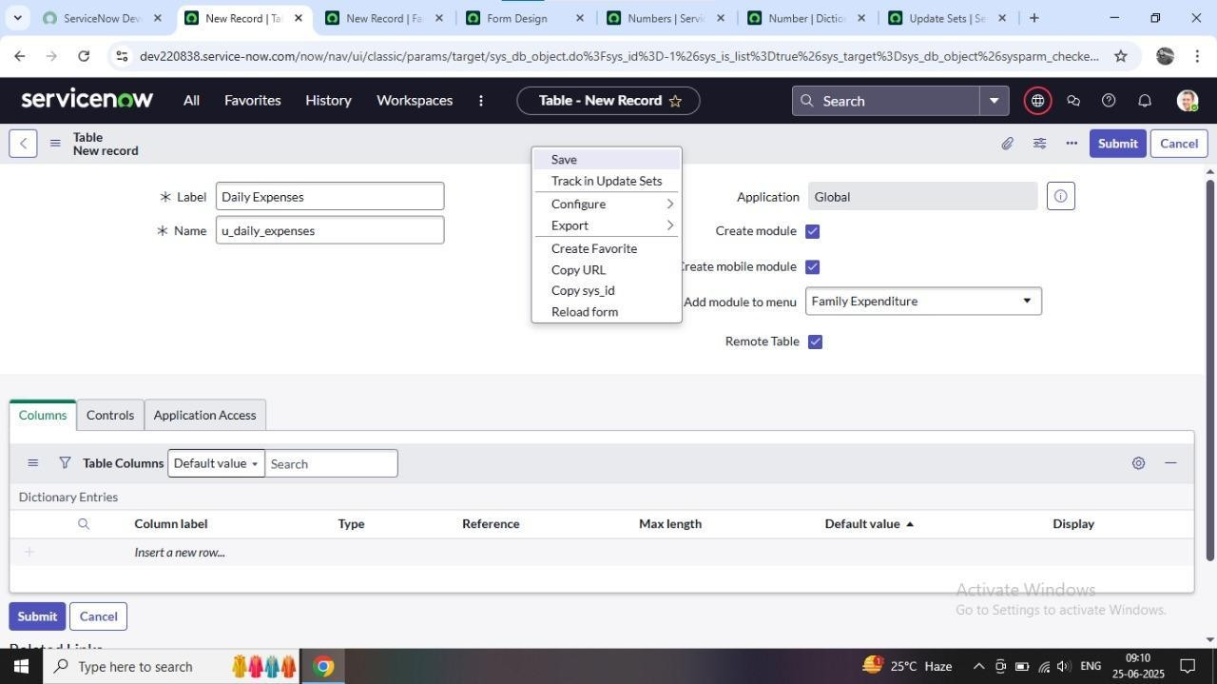

# CreationofColumn (Fields):

**KeyObjective:**Structureandorganizedailyfinancialdatainawaythatsupportsaccurateentry, easy tracking, and efficient reporting of daily spending activities.

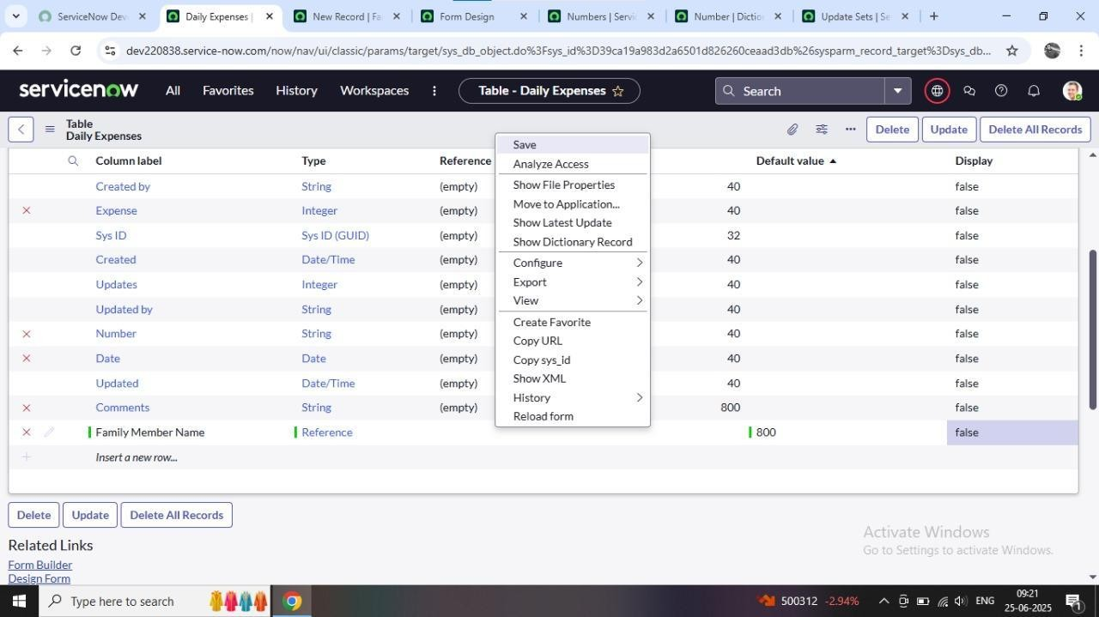

# MakingNumberFieldAn Auto-Number:

**KeyObjective:**Automaticallygenerateauniqueandsequentialidentifierforeachdailyexpense record,ensuringeasytracking,organization,andreferenceofindividualentrieswithoutmanual effort.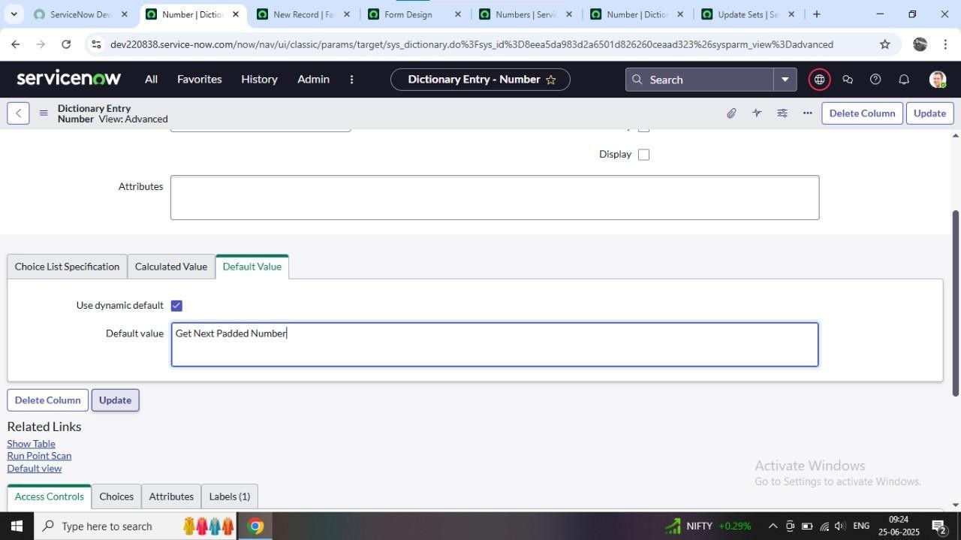

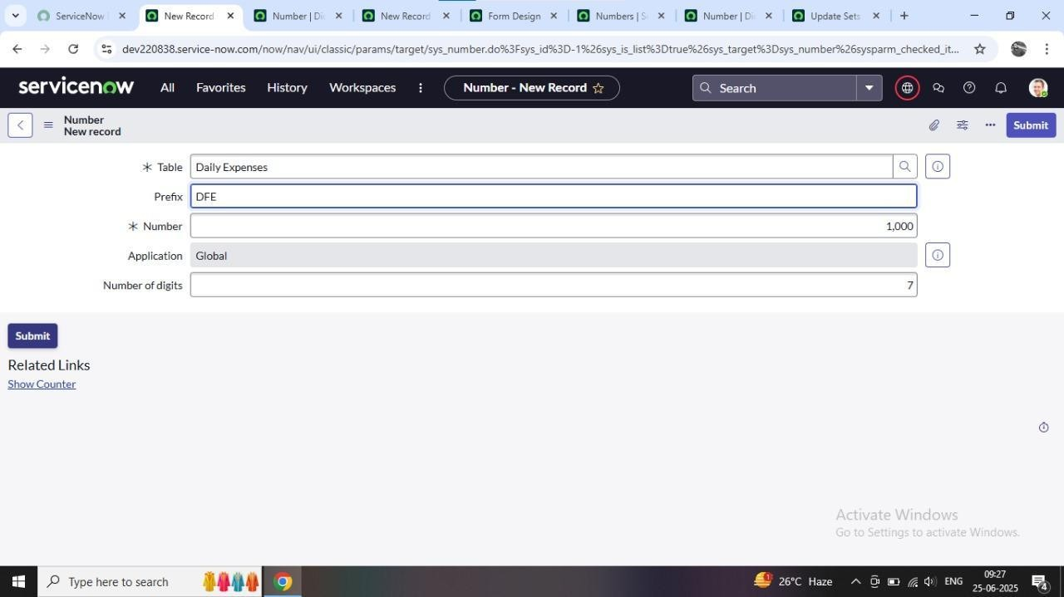

# Configurethe Form:

**KeyObjective:**Designauser-friendly,well-organizedinterfacethatmakesiteasytoinput,view, and manage daily expense records accurately and efficiently.

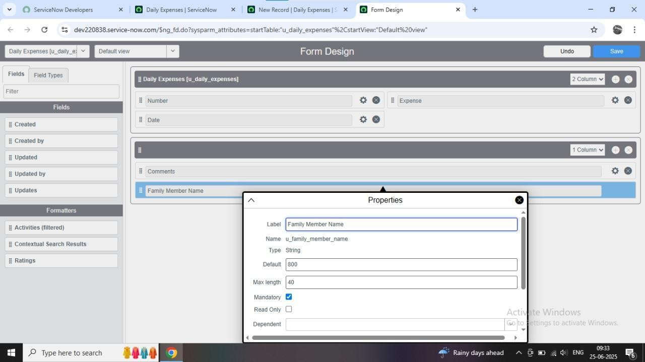

# Step-5:CreationofRelationshipBetweenFamilyExpensesAndDailyExpenses Tables

**KeyObjective:**Establishalogicallinkbetweeneachdailyexpenseandthecorrespondingfamily member,allowingforbetterdataorganization,tracking,andreportingofexpensesbyindividual or household.

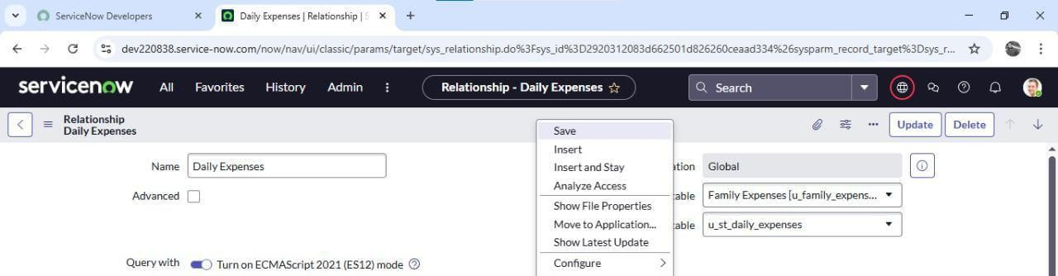

# Step-6:ConfiguringRelatedListonFamilyExpenses:

**KeyObjective:**DisplayallrelatedDailyExpensesrecordforeachfamilymemberdirectlywithin their family expenses form, enabling users to view and manage associated expense entries in one place.

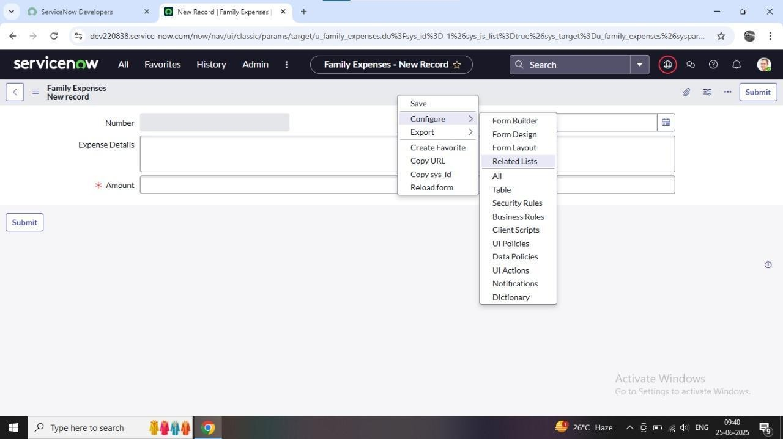

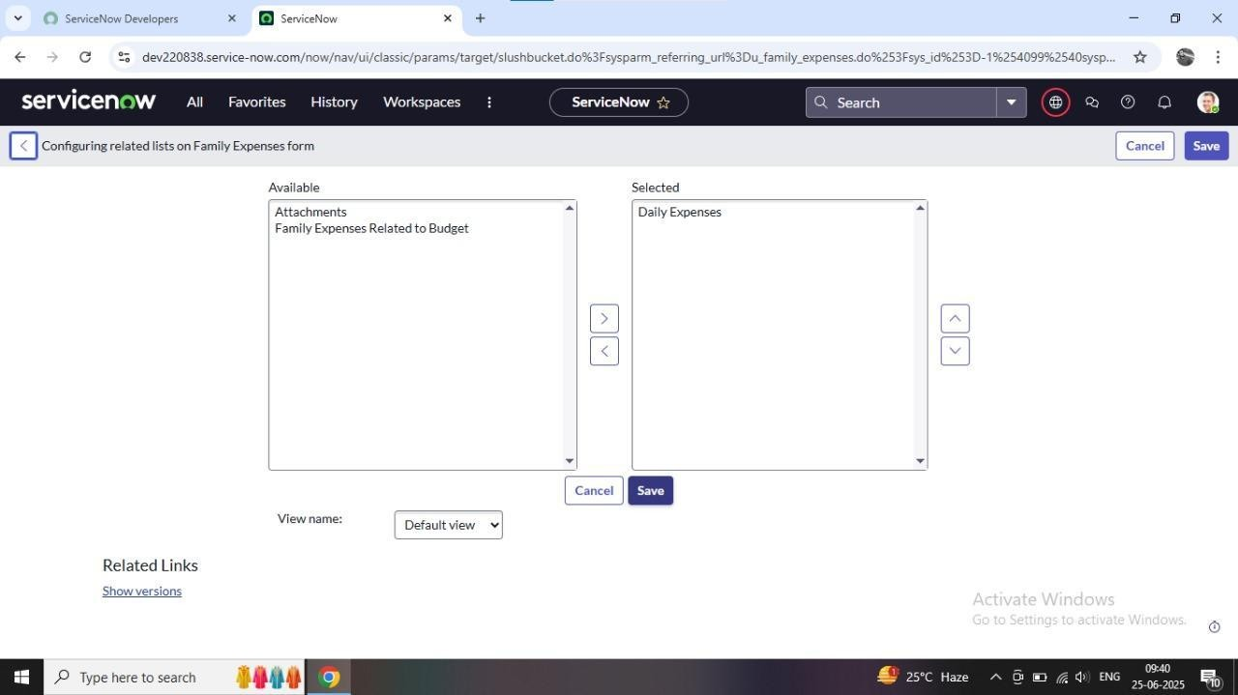

# Step-7:CreationofBusiness Rules:

**KeyObjective**:Automatebackendlogicandenforcebusinessprocessesbyexecutingcustom scripts when records are created, updated, deleted, or queried ensuring data consistency, validation,andprocessautomation.

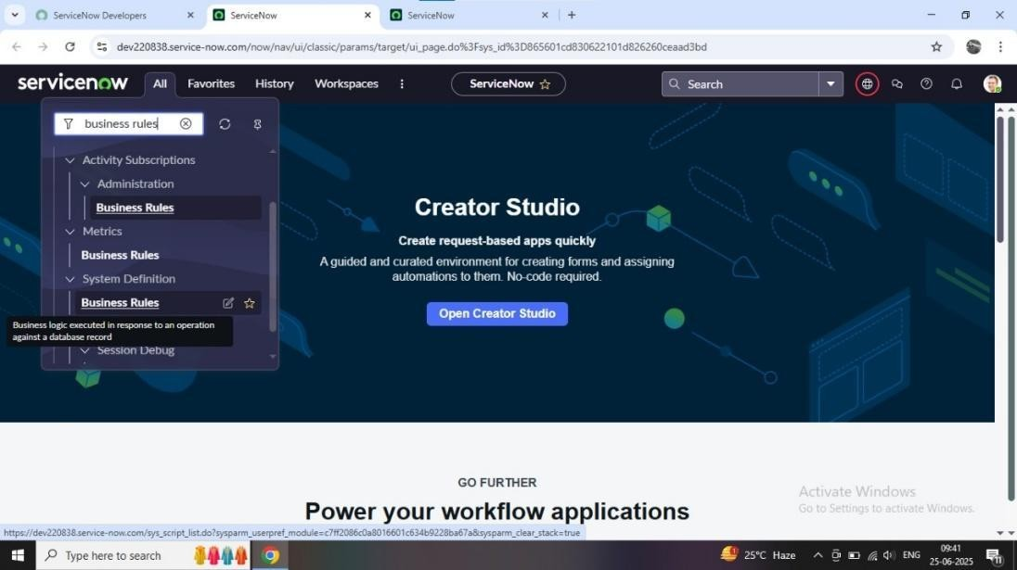

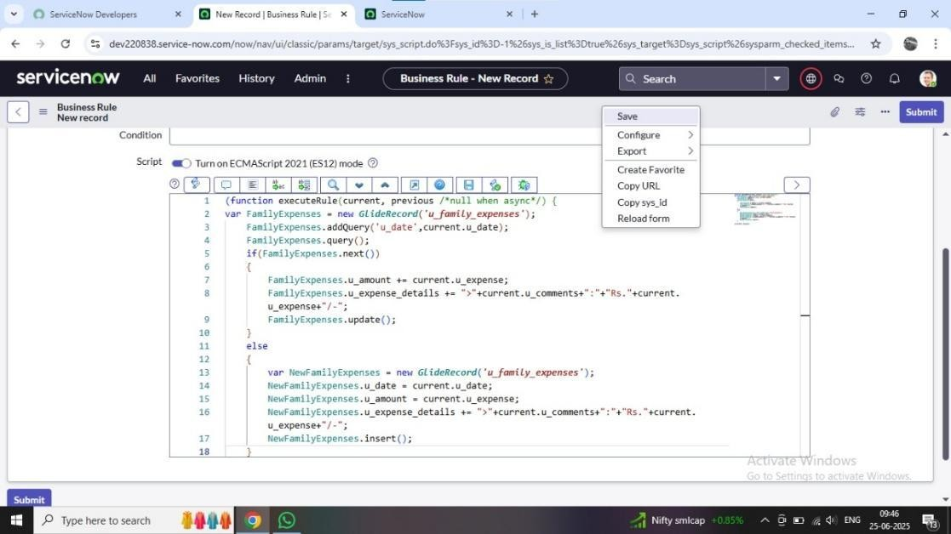

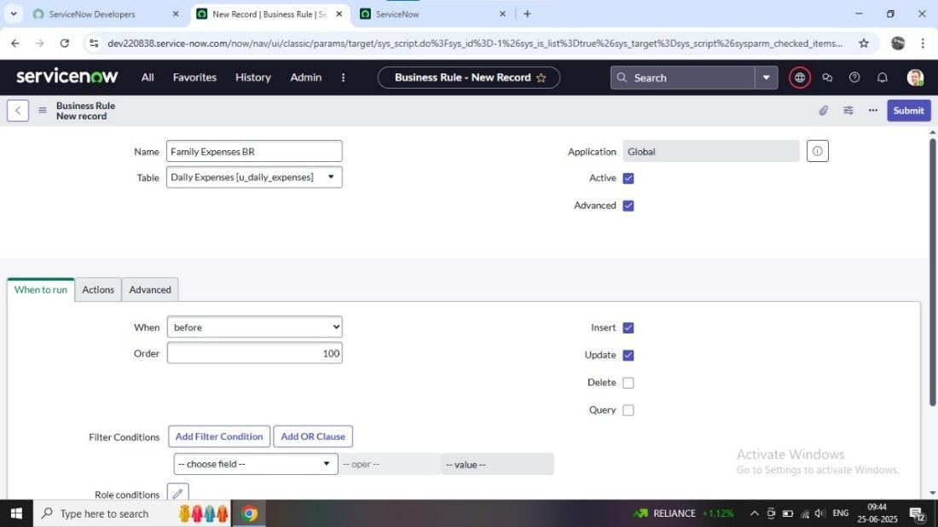

# Step-8:Configurethe Relationship:

**KeyObjective:**Logicallyconnecttworelatedtablessodatacanbelinked,referenced,and accessed easily supporting better data structure, consistency, and reporting.

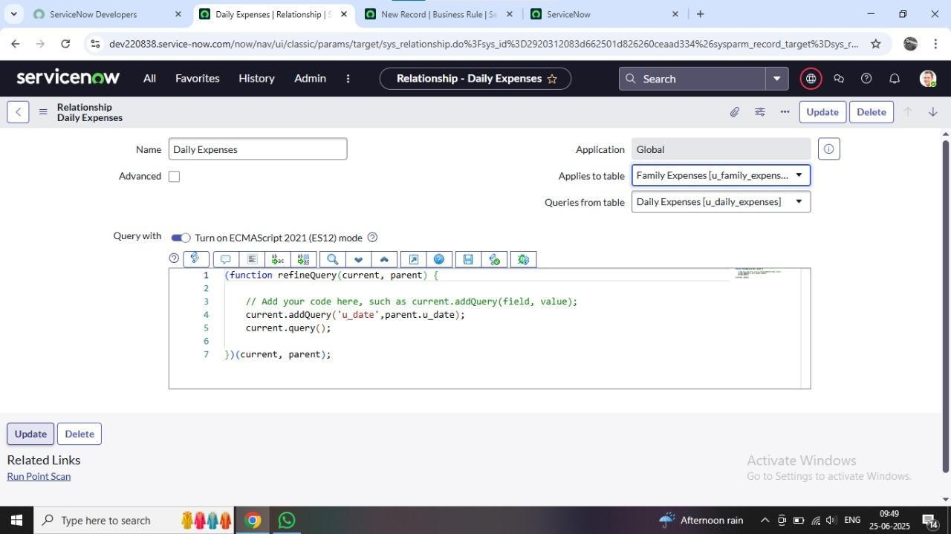

**Step-9:Conclusion:**

